Research Report

# 1. Research Question

My theoretical hypothesis was that Arnold Schwarzenegger and Sylvester Stallone are both great actors, and because they are both great, the effect size (standardized difference of their means) is not bigger than 0.8 or smaller than -0.8 (large effect sizes). I decided not to exclude outliers because in the case of Stallone there are movie titles which had a huge impact in his career (Rocky I) and from my view Arnold had a more constant advancement rate in Hollywood, this can be seen in the next figure plotted for the whole data which was gathered.

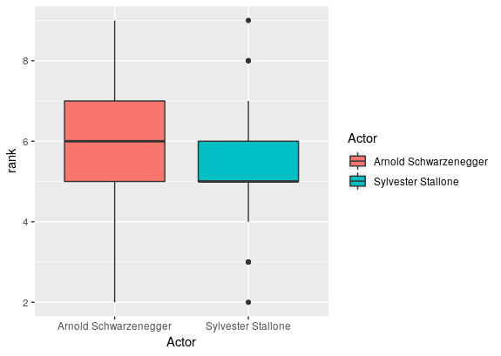

# 2. Tests Conducted

For a 90% power “two one sided tests” (TOST), an alpha equal to 0.05 we sampled 34 movie titles from both artists and got the result in R,

*Equivalence Test Result:*

*The equivalence test was significant, t(65.49) = -2.584, p = 0.006, given equivalence bounds of -1.043 and 1.043 (on a raw scale) and an alpha of 0.05.*

*Null Hypothesis Test Result:*

*The null hypothesis test was non-significant, t(65.49) = 0.714, p = 0.478, given an alpha of 0.05.*

*Based on the equivalence test and the null-hypothesis test combined, we can conclude that the observed effect is statistically not different from zero and statistically equivalent to zero.*

and the following graph which shows the equivalence test’s results.

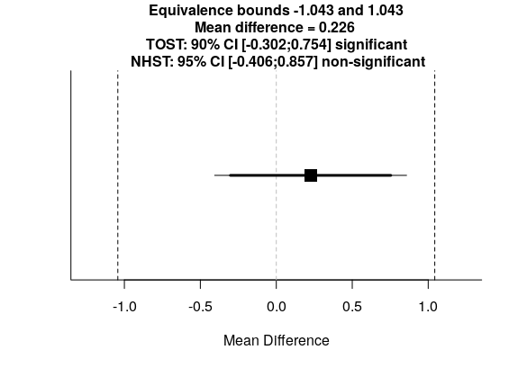

# 3. Conclusion

There null hypothesis for the zero mean difference seems justified and since the “TOSTtwo” test was found to be significant, both actors are equal in worth in the public eye!